Pattern of exam: QVQVQ-- 5 sections
Report received for the same.
FULL VERBAL REPORT.

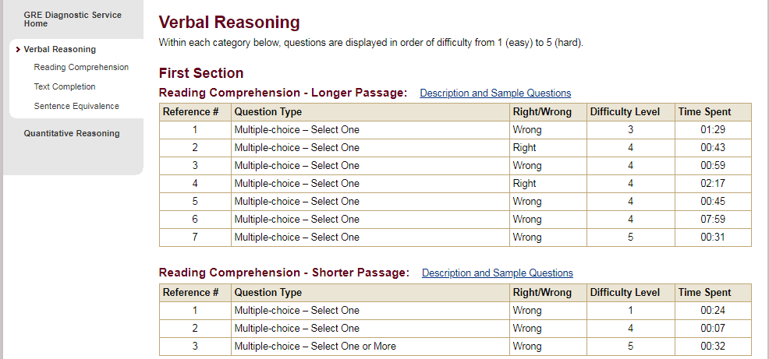
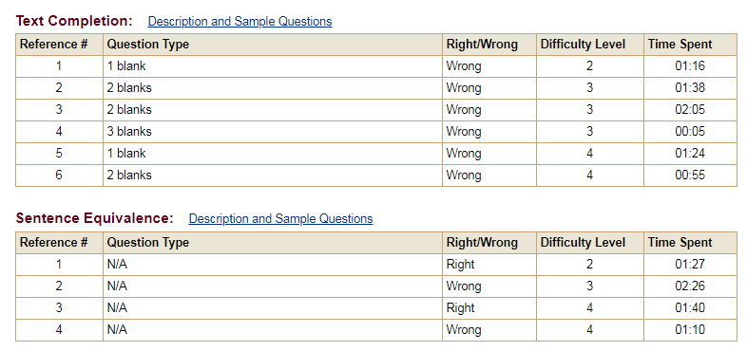
4 out of 20..(not good ) more 3 to 4 marks could have made difference.

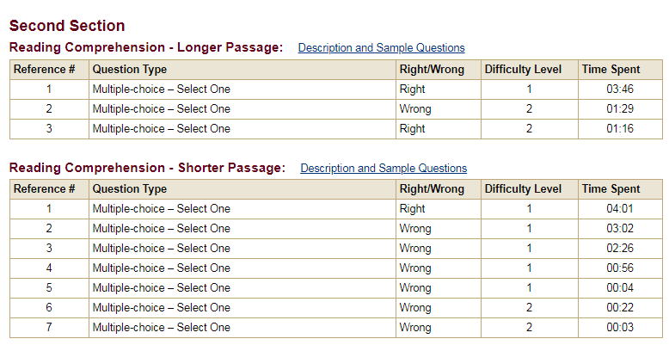
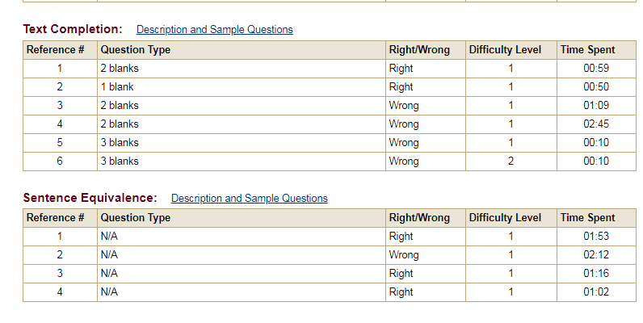

Section being easy ,scored 8 /20 and My total score was 12 /40, since ended up with easy section, total score will be deducted by 2-3 marks , i my case 2..
verbal Diagnostic report is in sync with my thought process.

FULL QUANTITATIVE REPORT.
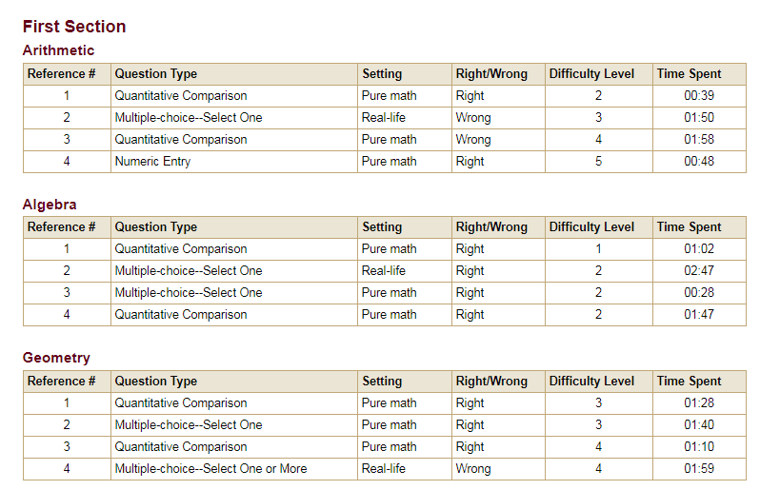
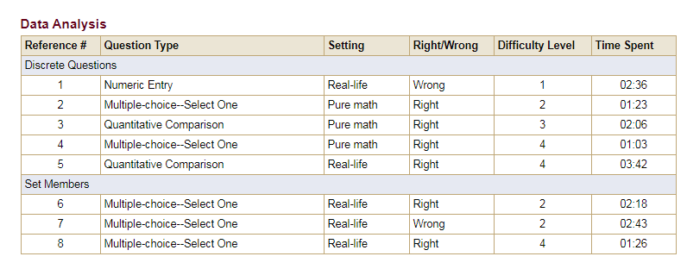
15 /20 (could have been better), expected outcome is to receive a medium or hard section.
after my first section performance i received 2 quant sections, if Suppose my second Q section was hard or medium (as i can recollect it went well )
final 3rd Q section was the also good from my end.
Questions which still flummox is ?
1. Section adapt to easy
2. Scoring (Even if i assume for a moment i did pretty bad may be less than 10 in second section and ended up with easy) i would have deduct in total score thats 30 -minus something= 24
it means i was deducted a score of 6 from my final score to land 154?? weird.



